Aurora's Higher Education and Research Academy
Uppal, Hyderabad, Telangana, +91 9100123456, aurora.edu.in
DEPARTMENT OF COMPUTER SCIENCE AND ENGINEERING - ARTIFICIAL INTELLIGENCE AND MACHINE LEARNING
COMPREHENSIVE PROJECT DEMONSTRATION
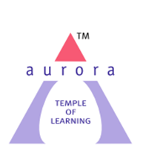
FOUNDATIONS OF DATA SCIENCE

PROJECT TITLE
Basic Calculator Using GUI
LEARNING GROUP NO: 1
INTERNAL GUIDE: Mr. Pranay Vemula, Assistant Professor, Dept. of CSE

NAME: M. Sai Vardhan Reddy
ROLL NO: 241U1R3001
Mob num: 9063205222
Email id: maramsaivardhanreddy@gmail.com

NAME: G. Manasa
ROLL NO: 241U1R3007
Mob num: 8988199666
Email id: gmanasa125@gmail.com

Demonstration:
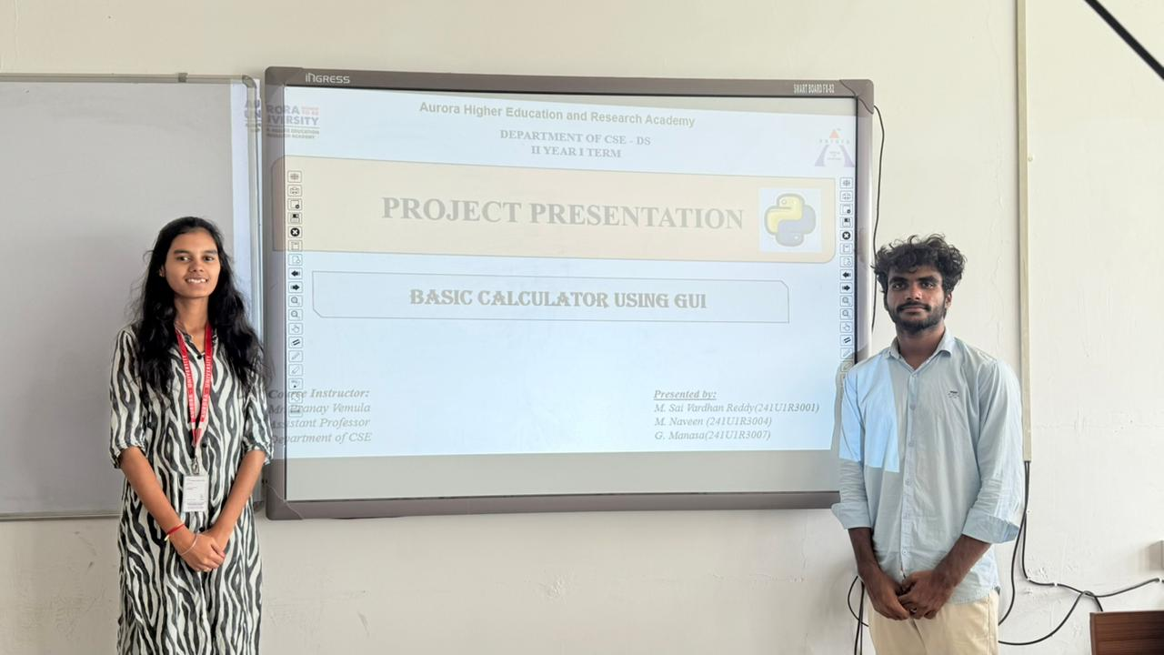
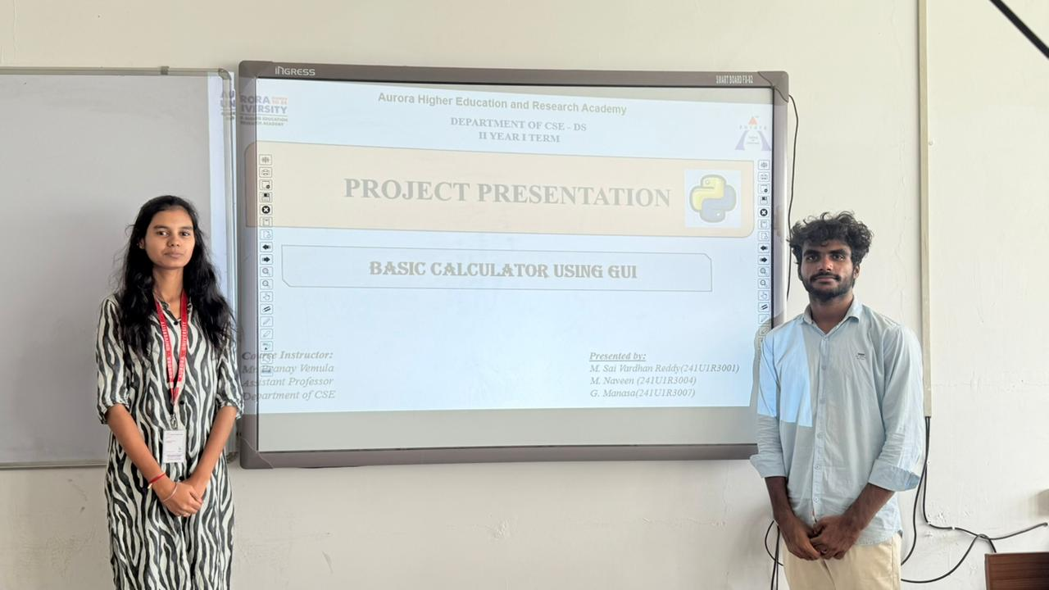

Questions asked by external:
- Which library used :
Ans: Tkinter library
- Which layout used:
Ans: Grid layout.
- How you are displaying the input:
Ans: display.get
4.what is the difference between Basic calculator & Scientific calculator:
Ans: Basic Calculator Used for simple arithmetic like addition, subtraction, multiplication, and division.
Scientific Calculator Can do everything advanced functions like trigonometry (sin, cos, tan), logarithms, powers, roots, factorials, and complex calculations.
5. How does it differ from the button layout of a basic calculator:
Ans: A basic calculator has only a few buttons: digits (0–9), decimal point, and basic operations (+, −, ×, ÷)

Output:
